### Name and Roll No: Batch: A2

Akshata Ingalahalli -16010421035

Surabhi Lele -16010421047

Siddhi Lokare -16010421048

### Home page code:

<!<!DOCTYPE html>

<html lang="en">

<head>

<meta charset="UTF-8">

<meta http-equiv="X-UA-Compatible" content="IE=edge">

<meta name="viewport" content="width=device-width, initial-scale=1.0">

<title>Document</title>

<script src="https://kit.fontawesome.com/bca19b6e15.js" crossorigin="anonymous"></script>

<style>

.topnav{

box-sizing: border-box;

overflow: hidden;

z-index: 1;

/* background-color: rgba(255, 255, 255, 0.8); */

}

.topnav a{

float: right;

color:black;

text-align: center;

padding: 18px 35px;

font-size: 23px;

text-decoration: none;

font-family:Georgia, 'Times New Roman', Times, serif;

display: block;

cursor: default;

}

.topnav a:hover{

color:rgb(242, 0, 255);

}

ul {

list-style-type: none;

margin: 0;

padding: 0;

}

li {

display: inline;

float: right;

}

li a{

color:black;

text-align: center;

padding: 18px 35px;

font-size: 23px;

text-decoration: none;

font-family:Georgia, 'Times New Roman', Times, serif;

display: block;

cursor: default;

transition: 0.3s;

}

li a:hover{

color:#CD5C5C;

border-radius: 10px;

border-color: black;

background-color:snow;

color:#CD5C5C;

-webkit-border-radius: 15pxpx;

-moz-border-radius: 15px;

border-radius: 26px;

}

/*.video-container video{

right: 0;

left: 0;

top: 0;

width: 100%;

height: 100vh;

background-position: center;

overflow: hidden;

z-index: -100;

position: absolute;

}*/

/*.overlay {

position: absolute;

top: 0;

left: 0;

width: 50%;

height: 100%;

background-image: linear-gradient(to left, rgba(0, 0, 0, 0.6), rgba(0, 0, 0, 0.2));

}*/

/* .video-cont{

position: relative;

} */

/* .video-cont1{

position: absolute;

height: 100%;

width: 100%;

} */

.video-container {

position: relative;

width: 100vh;

height: 100vh;

background-size: cover;

}

#myvideo{

position: absolute;

right: 0;

bottom: 0;

/* min-width: 100vh;

min-height: 100vh; */

width: 100%;

z-index: -100;

background-image: linear-gradient(to right, rgba(0, 0, 0, 1), rgba(0, 0, 0, 0.1));

}

.video-container video {

position: absolute;

top: 0;

left: 0;

width: 100vh;

height: 100vh;

z-index: -100;

overflow: hidden;

background-position: center;

background-size: cover;

}

.overlay {

position: absolute;

top: 0;

left: 0;

width: 100%;

height: 100%;

background-image: linear-gradient(to right, rgba(0, 0, 0, 1), rgba(0, 0, 0, 0.1));

}

body{

margin: 0;

background-size: cover;

background: linear-gradient(lightpink, lavender);

}

.textbox{

position: relative;

width: 45%;

height: 50%;

color:indianred;

padding-left: 50px;

padding-top: 40px;

font-size: 26px;

}

.textbox .text{

font-size: 25px;

line-height: 1.5;

font-weight: 80;

color: lavender;

}

#scroll-down-btn{

position: absolute;

cursor: pointer;

margin-top: 70px;

margin-left: 200px;

padding-top: 10px;

padding-bottom: 10px;

padding-left: 10px;

padding-right: 10px;

border-radius: 20px;

border:3px solid #CD5C5C;

background: transparent;

z-index: 1;

transform: translate(-50%,-50%);

}

#scroll-down-btn .text1{

font-size: 20px;

font-weight: 500;

font-family: Georgia, 'Times New Roman', Times, serif;

transition: .3s;

color: lavender;

}

#scroll-down-btn:hover{

box-shadow: 0 0 5px 0 #CD5C5C inset, 0 0 4px 2px #CD5C5C;

border: 3px solid #CD5C5C;

}

#yoga{

width: 420px;

top: 100%;

padding-top: 15%;

padding-left: 65%;

padding-bottom: 10%;

position: absolute;

}

.choose{

position: absolute;

color: rgb(12, 11, 11);

top: 100%;

padding-left: 40%;

padding-top: 5%;

font-family: Georgia, 'Times New Roman', Times, serif;

font-size: 30px;

font-weight: 80;

}

.yogah{

position: absolute;

color: rgb(12, 11, 11);

top: 100%;

padding-left: 19%;

padding-top: 16%;

font-family: Georgia, 'Times New Roman', Times, serif;

font-size: 30px;

font-weight: 80;

width: 40%;

}

.yoga-content{

position: absolute;

color: rgb(12, 11, 11);

top: 100%;

padding-left: 5%;

padding-top: 22%;

font-family: Georgia, 'Times New Roman', Times, serif;

font-size: 25px;

font-weight: 80;

width: 40%;

}

.my-button{

position: absolute;

top: 100%;

margin-top: 31%;

margin-left: 17%;

border-radius: 20px;

border: 3px solid #CD5C5C;

background: transparent;

padding: 10px 20px;

cursor: pointer;

font-size: 18px;

font-weight: 550;

transition: 0.4s;

}

.my-button:hover{

color: black;

font-size: 1.2rem;

background-color:#CD5C5C;

color: aliceblue;

}

.b1 {

border: 2px solid #7f4545;

padding: 20px;

width: 700px;

height: 300px;

top: 100%;

margin-top: 35%;

margin-left: 7% ;

box-shadow: 0px 0px 4px;

}

.b2{

border: 2px solid #7f4545;

padding: 20px;

width: 700px;

height: 300px;

top: 80%;

margin-left: 40%;

margin-top: 7%;

margin-bottom: 10%;

box-shadow: 0px 0px 4px;

}

#strength-training_compressed{

width: 30%;

padding-top: 8%;

padding-right: 65%;

padding-left: 6%;

padding-bottom: 10%;

position: absolute;

height: 300px;

}

.strh{

padding-left: 35%;

padding-top: 5%;

font-family: Georgia, 'Times New Roman', Times, serif;

font-size: 30px;

font-weight: 80;

}

.str-content{

padding-top: 5%;

font-family: Georgia, 'Times New Roman', Times, serif;

font-size: 25px;

font-weight: 80;

width: 80%;

padding-left: 7%;

}

.str-button{

border-radius: 20px;

border: 3px solid #CD5C5C;

background: transparent;

cursor: pointer;

position: absolute;

top: 100%;

margin-top: 63%;

margin-left: 20%;

border-radius: 20px;

font-size: 18px;

font-weight: 550;

padding: 10px 20px;

transition: 0.4s;

}

.str-button:hover{

color: black;

font-size: 1.2rem;

background-color:#CD5C5C;

color: aliceblue;

}

#cardio{

width: 420px;

padding-left: 65%;

padding-bottom: 10%;

position: absolute;

margin-top: 4%;

}

.b3{

border: 2px solid #7f4545;

padding: 20px;

width: 700px;

height: 300px;

margin-left: 7%;

margin-top: 4%;

margin-bottom: 10%;

box-shadow: 0px 0px 4px;

}

.cardioh{

padding-left: 40%;

padding-top: 5%;

font-family: Georgia, 'Times New Roman', Times, serif;

font-size: 30px;

font-weight: 80;

}

.cardio{

padding-top: 5%;

font-family: Georgia, 'Times New Roman', Times, serif;

font-size: 25px;

font-weight: 80;

width: 80%;

padding-left: 10%;

}

.cardio-button{

border-radius: 20px;

border: 3px solid #CD5C5C;

background: transparent;

cursor: pointer;

position: absolute;

top: 100%;

margin-top: 97%;

margin-left: 18%;

border-radius: 20px;

font-size: 18px;

font-weight: 550;

padding: 10px 20px;

transition: 0.4s;

}

.cardio-button:hover{

color: black;

font-size: 1.2rem;

background-color:#CD5C5C;

color: aliceblue;

}

.footer{

-webkit-filter: blur(4px);

backdrop-filter: blur(4px);

position: relative;

background-image: url("/Users/akshataingalahalli/Desktop/web/footer.jpg");

background-size: cover;

background-repeat: no-repeat;

background-position: center;

min-height: 500px;

width: 100%;

}

.contact{

color:azure;

backdrop-filter: blur;

}

@media (max-width: 768px) {

/* Adjust your styles for mobile here */

body {

font-size: 14px;

}

li {

display: block;

}

li a {

padding: 10px;

font-size: 18px;

}

.textbox {

width: 100%;

padding-left: 20px;

text-align: center;

}

.textbox .text {

font-size: 18px;

}

#scroll-down-btn {

display: none;

}

.choose {

padding-left: 10px;

}

.yogah {

width: 100%;

text-align: center;

}

.yoga-content {

width: 100%;

text-align: center;

}

.my-button {

margin-left: 35%;

}

.b1, .b2, .b3 {

width: 90%;

margin-left: 5%;

}

.strh, .cardioh {

text-align: center;

}

.str-content, .cardio {

width: 100%;

text-align: center;

}

.str-button, .cardio-button {

margin-left: 30%;

}

.footer {

background-size: contain;

background-position: top;

}

}

/* Media query for screens with a maximum width of 480px (smaller mobile devices) */

@media (max-width: 480px) {

/* Further adjustments for smaller screens go here */

body {

font-size: 10px;

background-color: rgba(0,0,0,0.5);

}

li a {

padding: 1px;

font-size: 15px;

}

.textbox {

font-size: 12px;

}

.yogah, .strh, .cardioh {

font-size: 10px;

}

.yoga-content, .str-content, .cardio {

font-size: 10px;

}

.my-button, .str-button, .cardio-button {

font-size: 8px;

}

ul {

list-style-type: none;

margin: 0;

padding: 0;

}

li {

display: block;

float: right;

}

li a{

color:black;

text-align: center;

padding: 1px;

font-size: 17px;

text-decoration: none;

font-family:Georgia, 'Times New Roman', Times, serif;

display: block;

cursor: default;

transition: 0.3s;

}

li a:hover{

color:#CD5C5C;

border-radius: 3px;

border-color: black;

background-color:snow;

}

h1{

font-size: 37px;

padding-top: 30px;

}

.video-container {

position: relative;

width: 100vh;

height: 100vh;

background-size: cover;

display: none;

}

text{

padding-left: 5px;

padding-right: 8px;

}

.choose {

font-size: 10px;

padding-top: 7px;

}

.container {

display: flex;

flex-direction: column;

align-items: center;

}

.card {

width: 90%;

padding: 10px;

margin: 10px;

}

#yoga,

#strength-training_compressed,

#cardio {

display: none;

}

.contact {

text-align: center;

}

.video-container {

display: none;

}

#yoga{

width: 420px;

top: 100%;

padding-top: 15%;

padding-left: 65%;

padding-bottom: 10%;

position: absolute;

}

.choose{

position: absolute;

color: rgb(12, 11, 11);

top: 100%;

padding-left: 40%;

padding-top: 5%;

font-family: Georgia, 'Times New Roman', Times, serif;

font-size: 30px;

font-weight: 80;

}

.yogah{

position: absolute;

color: rgb(12, 11, 11);

top: 100%;

padding-left: 18%;

padding-top: 16%;

font-family: Georgia, 'Times New Roman', Times, serif;

font-size: 30px;

font-weight: 80;

width: 40%;

}

.yoga-content{

position: absolute;

color: rgb(12, 11, 11);

top: 100%;

padding-left: 5%;

padding-top: 21%;

font-family: Georgia, 'Times New Roman', Times, serif;

font-size: 25px;

font-weight: 80;

width: 40%;

}

.my-button{

position: absolute;

top: 100%;

margin-top: 27%;

margin-left: 17%;

border-radius: 20px;

border: 3px solid #CD5C5C;

background: transparent;

padding: 10px 20px;

cursor: pointer;

font-size: 18px;

font-weight: 550;

transition: 0.4s;

}

.my-button:hover{

color: black;

font-size: 1.2rem;

background-color:#CD5C5C;

color: aliceblue;

}

.b1, .b2, .b3 {

width: 90%;

margin-left: 5%;

}

.b1 {

border: 0.5px solid #7f4545;

padding: 10px;

width: 300px;

height: 100px;

top: 100%;

margin-top: 47%;

margin-left: 7% ;

box-shadow: 0px 0px 4px;

}

.b2{

border: 0.5px solid #7f4545;

padding: 10px;

width: 300px;

height: 100px;

top: 80%;

margin-left: 40%;

margin-top: 7%;

margin-bottom: 10%;

box-shadow: 0px 0px 4px;

}

.b3{

border: 0.5px solid #7f4545;

padding: 10px;

width: 300px;

height: 100px;

margin-left: 7%;

margin-top: 4%;

margin-bottom: 10%;

box-shadow: 0px 0px 4px;

}

}

</style>

</head>

<link rel="stylesheet" href="fitness.css">

<body>

<!-- <nav>

<div class="topnav">

<a href="login.html">Program</a>

<a href="">About</a>

<a href="">Login</a>

<a href="">Sign Up</a>

</div>

</nav> -->

<!--

<ul>

<li><a href="login-2.html">Login</a></li>

<li><a href="program.html">Program</a></li>

<li><a href="bmi.html">BMI</a></li>

<li><a href="about.html">About</a></li>

</ul>

--->

<?php

$menuItems = [

'login.php' => 'Login',

'program.php' => 'Program',

'bmi.php' => 'BMI',

'about.php' => 'About',

'fitness_chatbot.html' => 'Chatbot'

];

// Loop through the menu items and create navigation links

foreach ($menuItems as $link => $label) {

echo '<li><a href="' . $link . '">' . $label . '</a></li>';

}

?>

<div class="video-cont">

<video autoplay muted loop id="myvideo">

<source src="D:\XAMPP\htdocs\WP2" type="video/mp4">

</video>

<div class="video-cont1" style="position: absolute; height: 100%; width: 60%; top: 0; background-image: linear-gradient(90deg,black,rgba(0, 0, 0, 0.7), rgba(0,0,0,0)) "></div>

</div>

<div class="video-cont">

<video autoplay muted loop id="myvideo">

<source src="fitness.mp4" type="video/mp4">

</video>

<div class="video-cont1" style="position: absolute; height: 100%; width: 60%; top: 0; background-image: linear-gradient(90deg, black, rgba(0, 0, 0, 0.7), rgba(0, 0, 0, 0));"></div>

</div>

<div class="textbox">

<h1>UNOFIT</h1>

<div class="text"> Welcomes and unites people of all ages, abilities, and goals around a methodology that is accessible and effective for all. We train, persevere, and progress together.

</div>

</div>

<button id="scroll-down-btn">

<div class="text1">Explore more</div>

</button>

<script>

var scrollDownBtn = document.getElementById('scroll-down-btn');

scrollDownBtn.addEventListener('click', function() {

window.scrollBy({

top: 720,

behavior:"smooth"

});

});

</script>

<div class="choose">Choose your workout type</div>

<video autoplay muted loop id="yoga">

<source src="yoga.mp4" type="video/mp4">

</video>

<div class="b1">

<div class="yogah">Yoga</div>

<div class="yoga-content">Yoga for Beginners to Advanced. First free session available. Click to know more.</div>

<button class="my-button" onclick="location.href='program.html'">Know More</button>

</div>

<video autoplay muted loop id="strength-training_compressed">

<source src="strength-training_compressed.mp4" type="video/mp4">

</video>

<div class="b2">

<div class="strh">Strength Training</div>

<div class="str-content">Strength training sessions available from Mon-Sat. Click to know the timings.</div>

<button class="str-button" onclick="location.href='program.php'">Know More</button>

</div>

<video autoplay muted loop id="cardio">

<source src="cardio.mp4" type="video/mp4">

</video>

<div class="b3">

<div class="cardioh">Cardio</div>

<div class="cardio">First free session available for Cardio. Click to know more. </div>

<button class="cardio-button" onclick="location.href='program.php'">Know More</button>

</div>

<div style="display: flex;align-items: center ; width: 100%; justify-content: center;min-height: 500px; background-image: url('footer.jpg'); background-repeat: no-repeat; background-size: cover; background-position: center;">

<div style="min-height: 500px; min-width: 100%; background-color: rgba(0,0,0,0.5); display: flex; ">

<h1 style="color: #fff; font-family: 'Times New Roman', Times, serif; margin-left: 6%;margin-top: 40px;">Contact</h1>

<h3 style="color: lavender; font-family: 'Times New Roman', Times, serif; padding-top: 7%; margin-left: -96px;">Instagram</h3><i class="fa-brands fa-instagram" style="color: rgb(181, 123, 166); margin-top: 122px;margin-left: 10px;"></i>

<h3 style="color: lavender; font-family: 'Times New Roman', Times, serif; padding-top: 10%; margin-left: -105px;">Facebook</h3><i class="fa-brands fa-facebook" style="color: rgb(181, 123, 166) ;margin-top: 165px;margin-left: 12px;"></i>

<h3 style="color: lavender; font-family: 'Times New Roman', Times, serif; padding-top: 13%; margin-left: -100px;">Twitter</h3><i class="fa-brands fa-twitter" style="color: rgb(181, 123, 166);margin-top: 210px;margin-left: 14px;"></i>

<h3 style="color: lavender; font-family: 'Times New Roman', Times, serif; padding-top: 16%; margin-left: -100px;">Phone number</h3><i class="fa-solid fa-phone" style="color: rgb(181, 123, 166);margin-top: 250px;margin-left: 15px;"></i>

<h3 style="color: lavender; font-family: 'Times New Roman', Times, serif; padding-top: 19%; margin-left: -130px;">Email</h3><i class="fa-solid fa-envelope" style="color: rgb(181, 123, 166);margin-top: 293px;margin-left: 17px;"></i>

<h1 style="color: #fff; font-family: 'Times New Roman', Times, serif; margin-left: 12%;margin-top: 40px;">Quick Links</h1>

<h3 style="color: lavender; font-family: 'Times New Roman', Times, serif; padding-top: 7%; margin-left: -106px;">Login</h3><i class="fa-solid fa-right-to-bracket" style="color: rgb(181, 123, 166); margin-top: 122px;margin-left: 11px;"></i>

<h3 style="color: lavender; font-family: 'Times New Roman', Times, serif; padding-top: 10%; margin-left: -76px;">Cardio</h3><i class="fa-solid fa-heart-circle-bolt" style="color: rgb(181, 123, 166) ;margin-top: 165px;margin-left: 12px;"></i>

<h3 style="color: lavender; font-family: 'Times New Roman', Times, serif; padding-top: 13%; margin-left: -100px;">Strength Training</h3><i class="fa-solid fa-dumbbell" style="color: rgb(181, 123, 166);margin-top: 210px;margin-left: 14px;"></i>

<h3 style="color: lavender; font-family: 'Times New Roman', Times, serif; padding-top: 16%; margin-left: -148px;">Yoga</h3><i class="fa-regular fa-heart" style="color: rgb(181, 123, 166);margin-top: 250px;margin-left: 15px;"></i>

<h3 style="color: lavender; font-family: 'Times New Roman', Times, serif; padding-top: 7%; margin-left: 150px;">chat with us</h3><i class="fa-solid fa-message" style="color: rgb(181, 123, 166); margin-top: 122px;margin-left: 20px;"></i>

<h3 style="color: lavender; font-family: 'Times New Roman', Times, serif; padding-top: 10%; margin-left: -130px;">Explore more</h3>

<h3 style="color: lavender; font-family: 'Times New Roman', Times, serif; padding-top: 13%; margin-left: -120px;">Our Community</h3>

<h3 style="color: lavender; font-family: 'Times New Roman', Times, serif; padding-top: 16%; margin-left: -130px;">What is UNOFIT</h3>

<h3 style="color: lavender; font-family: 'Times New Roman', Times, serif; padding-top: 7%; margin-left: 75px;">Join our community</h3>

<h3 style="color: lavender; font-family: 'Times New Roman', Times, serif; padding-top: 10%; margin-left: -120px;">Trainers</h3>

<h3 style="color: lavender; font-family: 'Times New Roman', Times, serif; padding-top: 13%; margin-left: -70px;">About us</h3>

<h1 style="color: #fff; font-family: 'Times New Roman', Times, serif; margin-left: 12%;margin-top: 40px;">Address</h1>

<h3 style="color: lavender; font-family: 'Times New Roman', Times, serif; padding-top: 7%; margin-left: -120px;">Unofit, B/vijaypath<br><br> - Delhi-110065</h3>

</div>

</div>

</body>

</html>DOCTYPE html>

<html lang="en">

<head>

<meta charset="UTF-8">

<meta http-equiv="X-UA-Compatible" content="IE=edge">

<meta name="viewport" content="width=device-width, initial-scale=1.0">

<title>Document</title>

<script src="https://kit.fontawesome.com/bca19b6e15.js" crossorigin="anonymous"></script>

</head>

<link rel="stylesheet" href="fitness.css">

<body>

<?php

$menuItems = [

'login.php' => 'Login',

'program.php' => 'Program',

'bmi.php' => 'BMI',

'about.php' => 'About',

'fitness_chatbot.html' => 'Chatbot'

];

// Loop through the menu items and create navigation links

foreach ($menuItems as $link => $label) {

echo '<li><a href="' . $link . '">' . $label . '</a></li>';

}

?>

<div class="video-cont">

<video autoplay muted loop id="myvideo">

<source src="D:\XAMPP\htdocs\WP2" type="video/mp4">

</video>

<div class="video-cont1" style="position: absolute; height: 100%; width: 60%; top: 0; background-image: linear-gradient(90deg,black,rgba(0, 0, 0, 0.7), rgba(0,0,0,0)) "></div>

</div>

<div class="video-cont">

<video autoplay muted loop id="myvideo">

<source src="fitness.mp4" type="video/mp4">

</video>

<div class="video-cont1" style="position: absolute; height: 100%; width: 60%; top: 0; background-image: linear-gradient(90deg, black, rgba(0, 0, 0, 0.7), rgba(0, 0, 0, 0));"></div>

</div>

<div class="textbox">

<h1>UNOFIT</h1>

<div class="text"> Welcomes and unites people of all ages, abilities, and goals around a methodology that is accessible and effective for all. We train, persevere, and progress together.

</div>

</div>

<button id="scroll-down-btn">

<div class="text1">Explore more</div>

</button>

<script>

var scrollDownBtn = document.getElementById('scroll-down-btn');

scrollDownBtn.addEventListener('click', function() {

window.scrollBy({

top: 720,

behavior:"smooth"

});

});

</script>

<div class="choose">Choose your workout type</div>

<video autoplay muted loop id="yoga">

<source src="yoga.mp4" type="video/mp4">

</video>

<div class="b1">

<div class="yogah">Yoga</div>

<div class="yoga-content">Yoga for Beginners to Advanced. First free session available. Click to know more.</div>

<button class="my-button" onclick="location.href='program.html'">Know More</button>

</div>

<video autoplay muted loop id="strength-training_compressed">

<source src="strength-training_compressed.mp4" type="video/mp4">

</video>

<div class="b2">

<div class="strh">Strength Training</div>

<div class="str-content">Strength training sessions available from Mon-Sat. Click to know the timings.</div>

<button class="str-button" onclick="location.href='program.php'">Know More</button>

</div>

<video autoplay muted loop id="cardio">

<source src="cardio.mp4" type="video/mp4">

</video>

<div class="b3">

<div class="cardioh">Cardio</div>

<div class="cardio">First free session available for Cardio. Click to know more. </div>

<button class="cardio-button" onclick="location.href='program.php'">Know More</button>

</div>

<div style="display: flex;align-items: center ; width: 100%; justify-content: center;min-height: 500px; background-image: url('footer.jpg'); background-repeat: no-repeat; background-size: cover; background-position: center;">

<div style="min-height: 500px; min-width: 100%; background-color: rgba(0,0,0,0.5); display: flex; ">

<h1 style="color: #fff; font-family: 'Times New Roman', Times, serif; margin-left: 6%;margin-top: 40px;">Contact</h1>

<h3 style="color: lavender; font-family: 'Times New Roman', Times, serif; padding-top: 7%; margin-left: -96px;">Instagram</h3><i class="fa-brands fa-instagram" style="color: rgb(181, 123, 166); margin-top: 122px;margin-left: 10px;"></i>

<h3 style="color: lavender; font-family: 'Times New Roman', Times, serif; padding-top: 10%; margin-left: -105px;">Facebook</h3><i class="fa-brands fa-facebook" style="color: rgb(181, 123, 166) ;margin-top: 165px;margin-left: 12px;"></i>

<h3 style="color: lavender; font-family: 'Times New Roman', Times, serif; padding-top: 13%; margin-left: -100px;">Twitter</h3><i class="fa-brands fa-twitter" style="color: rgb(181, 123, 166);margin-top: 210px;margin-left: 14px;"></i>

<h3 style="color: lavender; font-family: 'Times New Roman', Times, serif; padding-top: 16%; margin-left: -100px;">Phone number</h3><i class="fa-solid fa-phone" style="color: rgb(181, 123, 166);margin-top: 250px;margin-left: 15px;"></i>

<h3 style="color: lavender; font-family: 'Times New Roman', Times, serif; padding-top: 19%; margin-left: -130px;">Email</h3><i class="fa-solid fa-envelope" style="color: rgb(181, 123, 166);margin-top: 293px;margin-left: 17px;"></i>

<h1 style="color: #fff; font-family: 'Times New Roman', Times, serif; margin-left: 12%;margin-top: 40px;">Quick Links</h1>

<h3 style="color: lavender; font-family: 'Times New Roman', Times, serif; padding-top: 7%; margin-left: -106px;">Login</h3><i class="fa-solid fa-right-to-bracket" style="color: rgb(181, 123, 166); margin-top: 122px;margin-left: 11px;"></i>

<h3 style="color: lavender; font-family: 'Times New Roman', Times, serif; padding-top: 10%; margin-left: -76px;">Cardio</h3><i class="fa-solid fa-heart-circle-bolt" style="color: rgb(181, 123, 166) ;margin-top: 165px;margin-left: 12px;"></i>

<h3 style="color: lavender; font-family: 'Times New Roman', Times, serif; padding-top: 13%; margin-left: -100px;">Strength Training</h3><i class="fa-solid fa-dumbbell" style="color: rgb(181, 123, 166);margin-top: 210px;margin-left: 14px;"></i>

<h3 style="color: lavender; font-family: 'Times New Roman', Times, serif; padding-top: 16%; margin-left: -148px;">Yoga</h3><i class="fa-regular fa-heart" style="color: rgb(181, 123, 166);margin-top: 250px;margin-left: 15px;"></i>

<h3 style="color: lavender; font-family: 'Times New Roman', Times, serif; padding-top: 7%; margin-left: 150px;">chat with us</h3><i class="fa-solid fa-message" style="color: rgb(181, 123, 166); margin-top: 122px;margin-left: 20px;"></i>

<h3 style="color: lavender; font-family: 'Times New Roman', Times, serif; padding-top: 10%; margin-left: -130px;">Explore more</h3>

<h3 style="color: lavender; font-family: 'Times New Roman', Times, serif; padding-top: 13%; margin-left: -120px;">Our Community</h3>

<h3 style="color: lavender; font-family: 'Times New Roman', Times, serif; padding-top: 16%; margin-left: -130px;">What is UNOFIT</h3>

<h3 style="color: lavender; font-family: 'Times New Roman', Times, serif; padding-top: 7%; margin-left: 75px;">Join our community</h3>

<h3 style="color: lavender; font-family: 'Times New Roman', Times, serif; padding-top: 10%; margin-left: -120px;">Trainers</h3>

<h3 style="color: lavender; font-family: 'Times New Roman', Times, serif; padding-top: 13%; margin-left: -70px;">About us</h3>

<h1 style="color: #fff; font-family: 'Times New Roman', Times, serif; margin-left: 12%;margin-top: 40px;">Address</h1>

<h3 style="color: lavender; font-family: 'Times New Roman', Times, serif; padding-top: 7%; margin-left: -120px;">Unofit, B/vijaypath<br><br> - Delhi-110065</h3>

</div>

</div>

</body>

</html>

Home output:

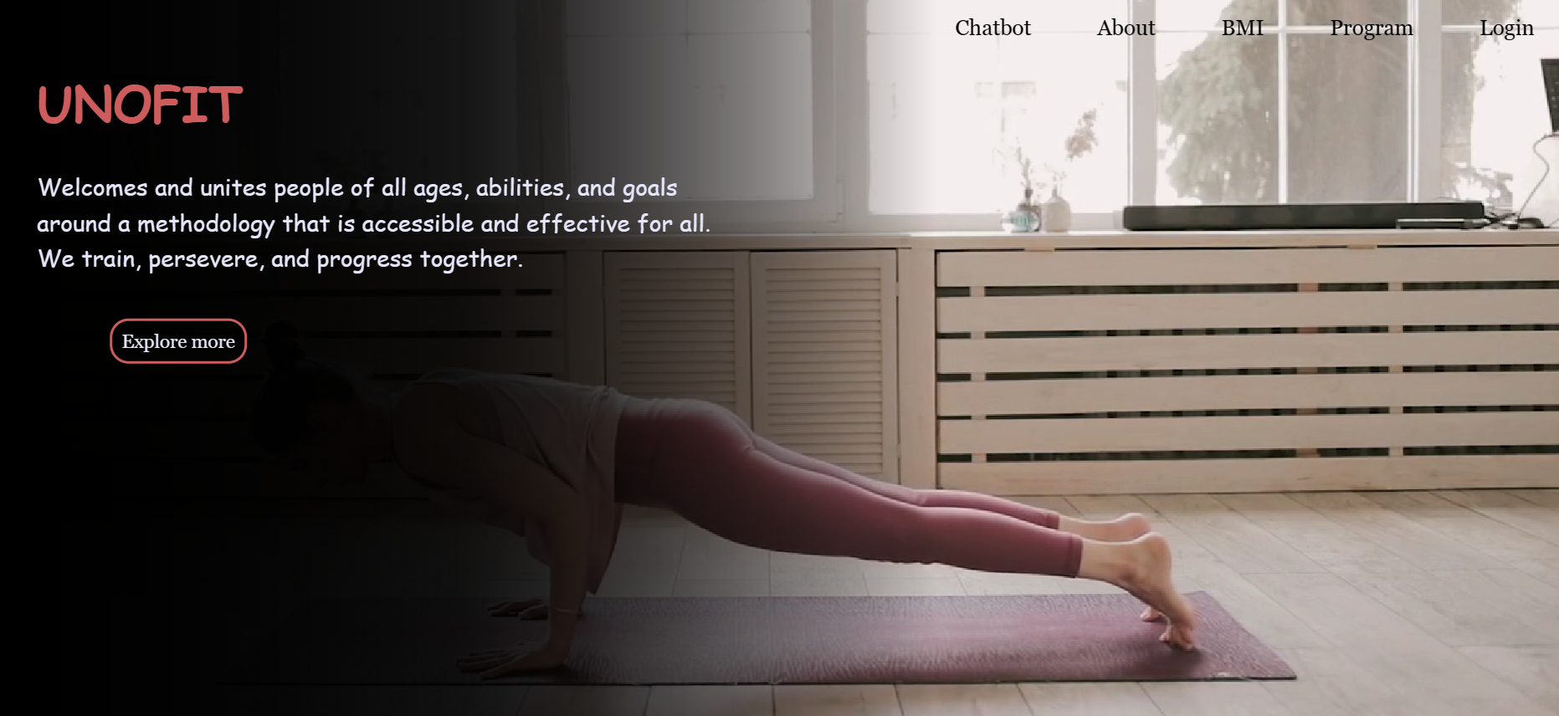

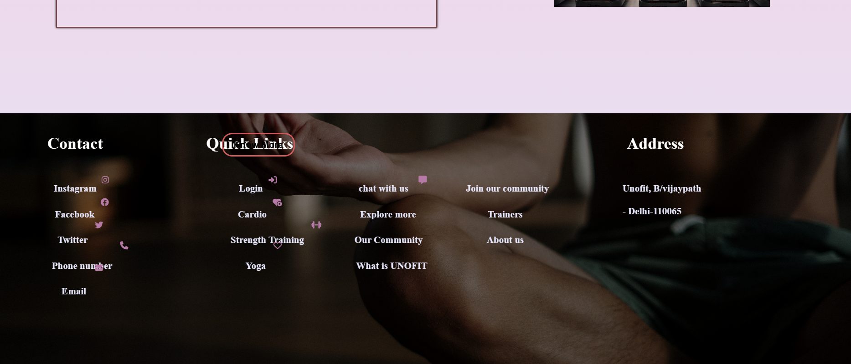

### About page code:

<!DOCTYPE html>

<html>

<head>

<meta name="viewport" content="width=device-width, initial-scale=1.0">

<title>About</title>

<link rel="stylesheet" href="style1.css">

</head>

<body>

<header>

<h1>About Us</h1>

</header>

<div class="container">

<div class="image-box">

<img alt="..." class="max-w-full rounded-lg shadow-lg" src="about.webp">

</div>

<div class="right">

<p id="slogan">"Fitness is a Journey, Enjoy the Ride"</p>

<p>

<?php

// Include your PHP content here

include('content.php');

echo "$websiteName is a dynamic and innovative fitness website that is dedicated to helping people achieve their fitness goals and lead a healthy and active lifestyle. $mission";

echo "At $websiteName, we believe that fitness should be accessible to everyone, regardless of their age, fitness level, or lifestyle. That's why we offer a range of fitness programs that cater to the needs of users at all levels, from beginners to advanced fitness enthusiasts. Whether you're looking to lose weight, build muscle, or simply improve your overall health and well-being, we have a program that can help you achieve your goals.";

echo "$teamInfo";

echo "We believe that fitness is more than just a physical activity - it's a way of life. That's why we offer a range of resources and tools to help users stay motivated, engaged, and committed to their fitness journey. From our online community forums to our fitness tracking tools, we provide users with the support and encouragement they need to stay on track and reach their goals.";

echo "At $websiteName, we are committed to excellence in everything we do. We strive to create a positive and empowering environment that inspires our users to push themselves to new heights and achieve their full potential. We are passionate about helping people live healthier, happier lives, and we look forward to being a part of your fitness journey.";

?>

</p>

</div>

<div class="btn-field">

<button type="button" id="Home" onclick="location.href='fitness.php'">Home</button>

<button type="button" id="Program" onclick="location.href='program.php'">Program</button>

<button type="button" id="Chatbot" onclick="location.href='fitness_chatbot.html'">Fitness Chatbot</button>

</div>

</div>

<footer>

<h3>@Unofit</h3>

</footer>

</body>

</html>

About page output:

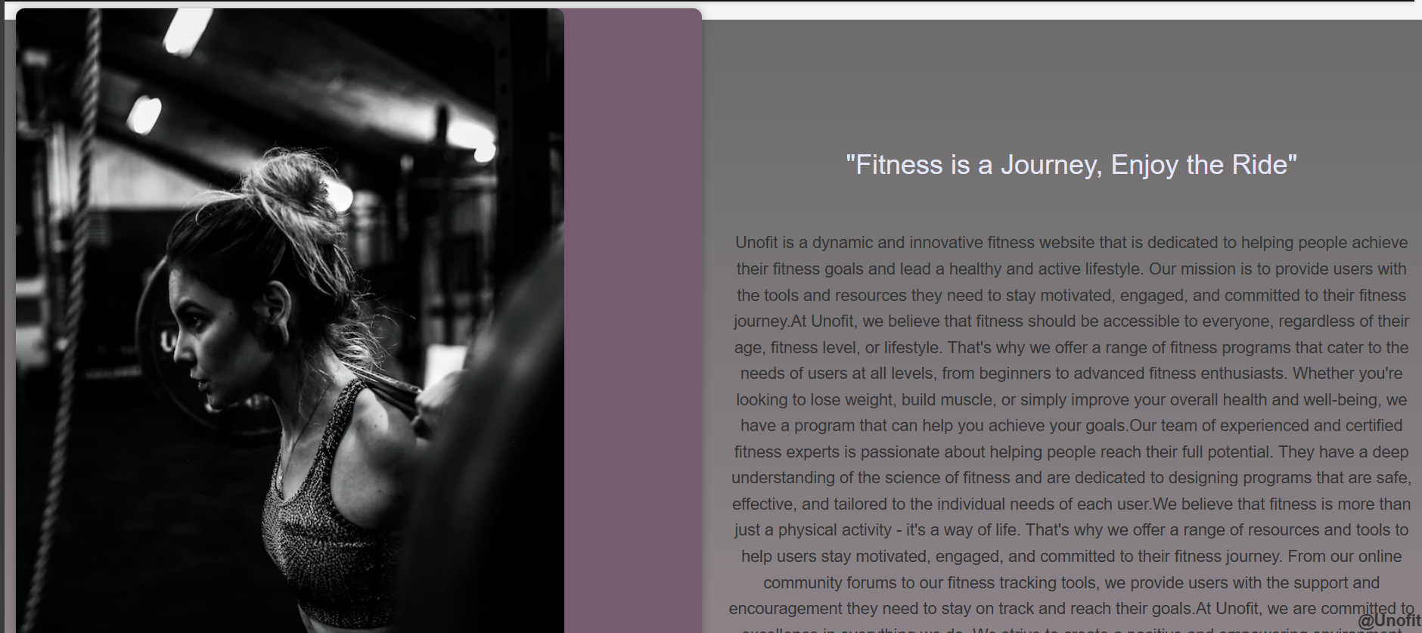

### Login page code:

<?php

if ($_SERVER["REQUEST_METHOD"] == "POST") {

$name = $_POST["name"];

$email = $_POST["email"];

$password = $_POST["password"];

// Perform validation here

$errors = [];

if (empty($name)) {

$errors[] = "Name is required";

}

if (!filter_var($email, FILTER_VALIDATE_EMAIL)) {

$errors[] = "Invalid email format";

}

if (strlen($password) < 6) {

$errors[] = "Password must be at least 6 characters long";

}

if (!empty($errors)) {

foreach ($errors as $error) {

echo $error . "<br>";

}

} else {

// Data is valid; you can proceed with registration

// Insert data into the database or perform other actions

// Redirect to program.php

header("Location: program.php");

exit; // Make sure to exit to prevent further script execution

}

}

?>

Login page output:

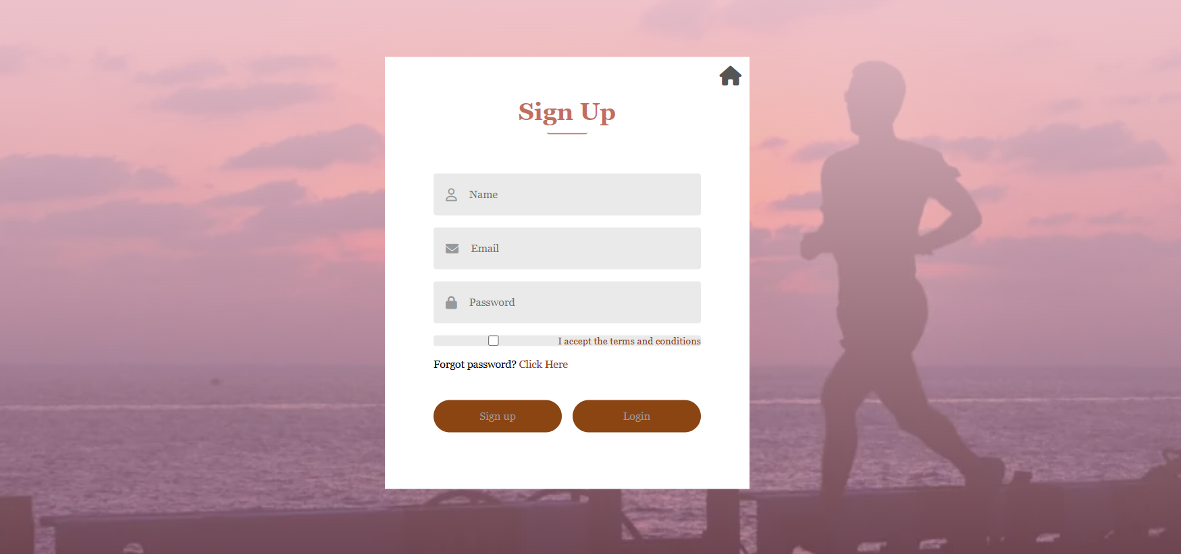

### 

### BMI code:

<!DOCTYPE html>

<html>

<head>

<title>BMI Calculator</title>

<script src="https://cdn.jsdelivr.net/npm/chart.js"></script>

<script src="https://kit.fontawesome.com/bca19b6e15.js" crossorigin="anonymous"></script>

</head>

<body>

<h1>BMI Calculator</h1>

<div class="content">

<form>

<label for="weight">Enter your weight in kilograms:</label>

<input type="text" id="weight" name="weight" required oninput="calculateBMI()"><br>

<label for="height">Enter your height in meters:</label>

<input type="text" id="height" name="height" step="0.01" required oninput="calculateBMI()"><br>

<input type="button" value="Calculate BMI" onclick="calculateBMI()"><br><br>

<label for="result">Your BMI:</label>

<input type="number" id="result" name="result" readonly>

<div id="status"></div>

</form>

<div class="homepage-link">

<a href="fitness.php"><i class="fas fa-home"></i></a>

</div>

<canvas id="bmi-chart"></canvas>

</div>

<script>

var status = "";

var chart; // Define chart outside of the function.

function calculateBMI() {

var weight = parseFloat(document.getElementById("weight").value);

var height = parseFloat(document.getElementById("height").value);

var bmi = weight / (height * height);

if (bmi < 18.5) {

status = "Underweight";

} else if (bmi < 25) {

status = "Normal";

} else if (bmi < 30) {

status = "Overweight";

} else {

status = "Obese";

}

document.getElementById("result").value = bmi.toFixed(2);

document.getElementById("status").innerHTML = status;

if (chart) {

chart.destroy(); // Destroy the existing chart before creating a new one.

}

chart = new Chart(document.getElementById("bmi-chart").getContext("2d"), {

type: "doughnut",

data: {

labels: ["Underweight", "Normal", "Overweight", "Obese"],

datasets: [{

data: [

getBMIStatusCount("Underweight"),

getBMIStatusCount("Normal"),

getBMIStatusCount("Overweight"),

getBMIStatusCount("Obese")

],

backgroundColor: [

"#3e95cd",

"#8e5ea2",

"#3cba9f",

"#e8c3b9"

],

borderWidth: 1

}]

},

options: {

legend: {

position: "bottom"

},

title: {

display: true,

text: "BMI Status Chart"

}

}

});

}

function getBMIStatusCount(status) {

var bmi = parseFloat(document.getElementById("result").value);

if (status === "Underweight" && bmi < 18.5) {

return 1;

} else if (status === "Normal" && bmi >= 18.5 && bmi < 25) {

return 1;

} else if (status === "Overweight" && bmi >= 25 && bmi < 30) {

return 1;

} else if (status === "Obese" && bmi >= 30) {

return 1;

} else {

return 0;

}

}

</script>

</script>

</body>

</html>

BMI OUTPUT:

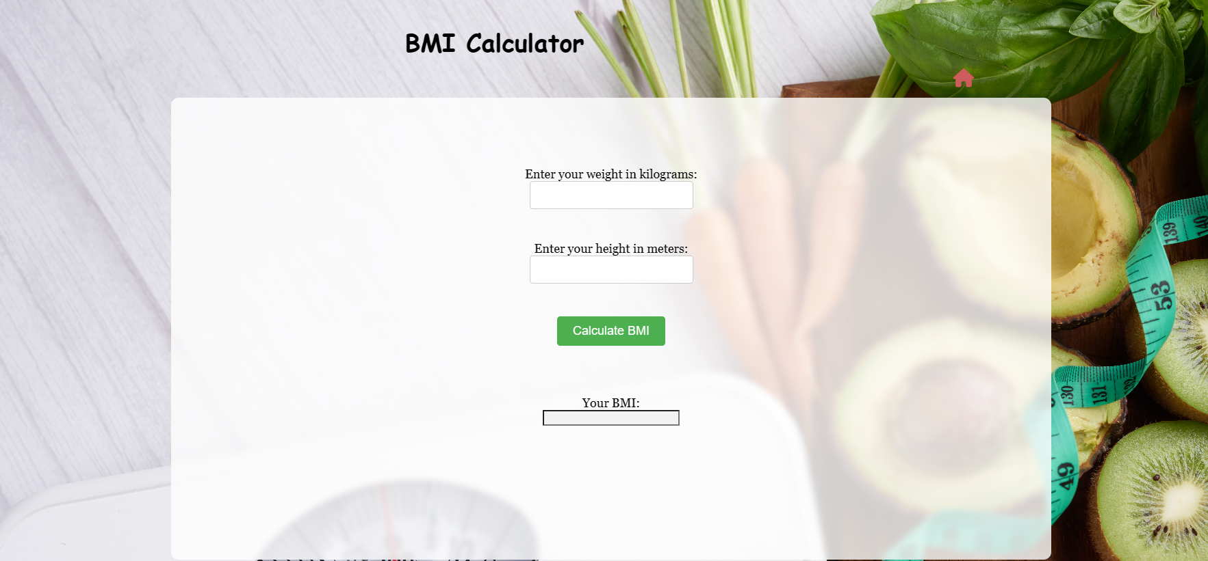

### Program code:

<!DOCTYPE html>

<html>

<head>

<title>Programs</title>

<link rel="stylesheet" href="style2.css">

<script src="https://kit.fontawesome.com/bca19b6e15.js" crossorigin="anonymous"></script>

</head>

<body>

<a href="fitness.php" id="home-link"><i class="fas fa-home"></i></a>

<h1>Programs</h1><hr><hr>

<img src="yoga.jpg" alt="Yoga1" id="yoga">

<div class="b1">

<div class="yogah">Yoga</div>

<div class="yoga-content">Yoga for Beginners to Advanced. First free session available.<br> Timings:<br> Online: 6:00am-7:00am 8:00am-9:00am <br> Offline: 10:00am-11:00am 4:00pm-5:00pm</div>

</div>

<img src="strength.jpg" alt="strength1" id="strength-training">

<div class="b2">

<div class="strh">Strength Training</div>

<div class="str-content">Strength training sessions available from Mon-Sat.<br> Timings: <br> 3:00pm-4:00pm 7:00pm-8:00pm</div>

</div>

<img src="cardio1.jpg" alt="cardio1" id="cardio">

<div class="b3">

<div class="cardioh">Cardio</div>

<div class="cardio">First free session available for Cardio.<br> Timings: <br> 6:00pm-8:00pm 8:00pm-10:00pm</div>

</div>

<p>Need more fitness advice? Ask our fitness chatbot!</p>

<a class="chat-icon" href="fitness_chatbot.html"><i class="fas fa-comments"></i></a>

<footer>

<h3>@Unofit</h3>

</footer>

</body>

</html>

Program Output:

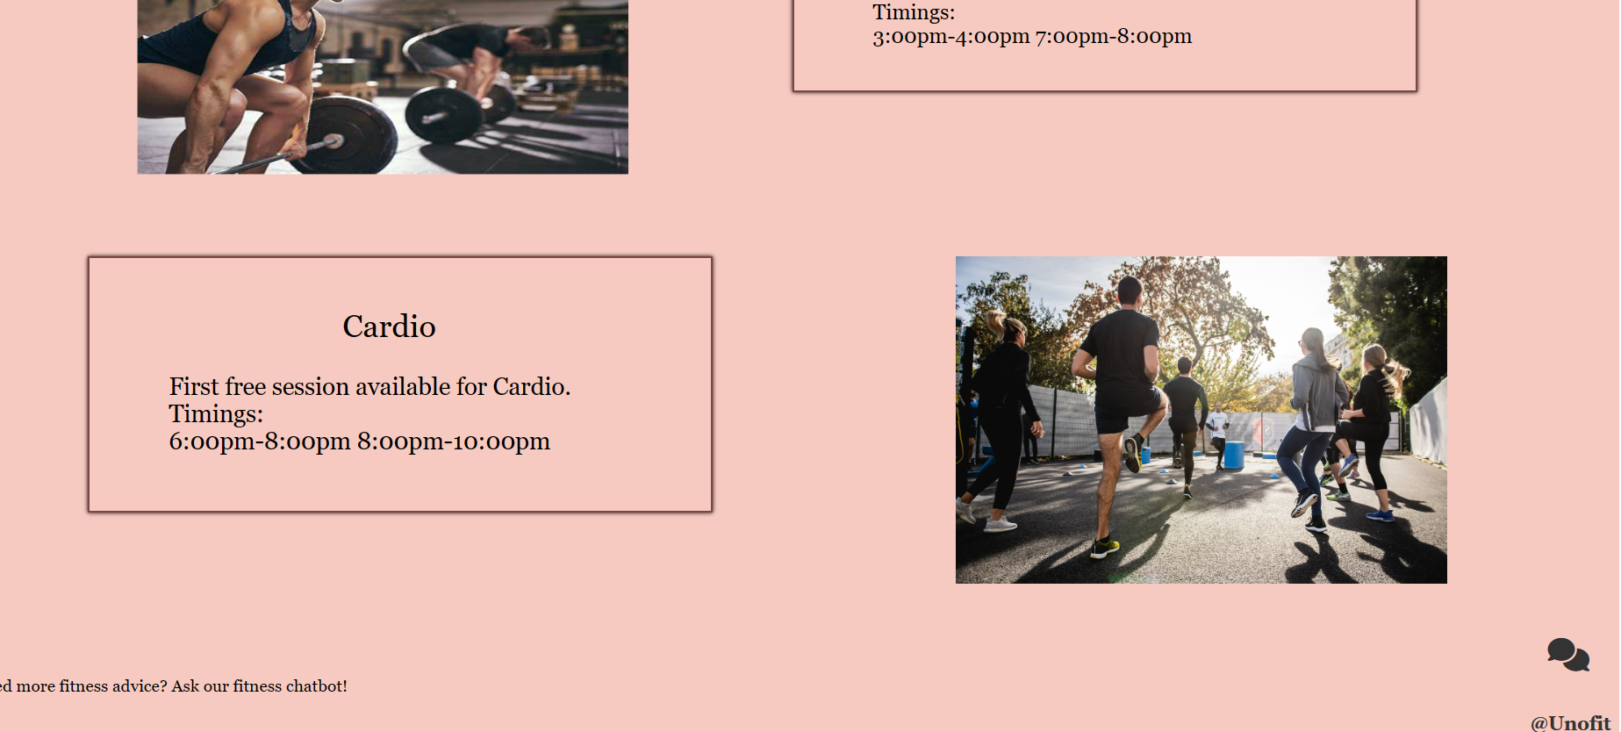

Chatbot Code:

<?php

$servername = "localhost";

$username = "root";

$password = ""; // Leave it empty if you haven't set a password

$database = "fitness_bot";

$conn = new mysqli($servername, $username, $password, $database);

if ($conn->connect_error) {

die("Connection failed: " . $conn->connect_error);

}

// Get user input

if (isset($_POST['user_message'])) {

$user_message = $_POST['user_message'];

if (!empty($user_message)) {

// Check if the user's message is a common greeting

$user_message = strtolower($user_message);

if (in_array($user_message, ['hello', 'hey', 'hi'])) {

// Custom response for common greetings

$bot_response = "Hello! How can I assist you today?";

} else {

// Check predefined answers

$query = "SELECT answer FROM predefined_answers WHERE keyword = ?";

if ($stmt = $conn->prepare($query)) {

$stmt->bind_param("s", $user_message);

$stmt->execute();

$stmt->bind_result($predefined_answer);

$stmt->fetch();

$stmt->close();

} else {

// Log errors to the PHP error log for debugging

error_log("MySQL Error: " . $conn->error);

$bot_response = "Error in processing your request. (Database Error)";

}

if (!empty($predefined_answer)) {

// Use predefined answer

$bot_response = $predefined_answer;

} else {

// Default response when no predefined answer is found

$bot_response = "I'm not sure how to respond to that. Please feel free to ask another question.";

}

}

echo json_encode(['bot_response' => $bot_response]);

} else {

echo json_encode(['bot_response' => "Please enter a message."]);

}

} else {

echo json_encode(['bot_response' => "Please enter a message."]);

}

// Close the database connection

$conn->close();

?>

Chatbot output:

